1. 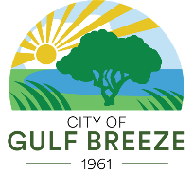**Stormwater Management FAQ**

**1. What is stormwater management?** Stormwater management involves controlling and using rainwater runoff to prevent flooding, reduce pollution, and protect water quality in local water bodies.

**2. Why is stormwater runoff a problem?** Stormwater runoff can carry pollutants like oil, fertilizers, pesticides, and trash into rivers, lakes, and streams, harming aquatic ecosystems and degrading water quality. It can also cause flooding and erode soil.

**3. How does stormwater runoff affect the environment?** Runoff can lead to:

a. Contamination of water bodies with pollutants.

b. Habitat destruction for aquatic and terrestrial species.

c. Algal blooms are caused by excess nutrients, which deplete oxygen in water and harm   
 marine life.

**4. What is a stormwater system?** A network of drains, pipes, and other infrastructure designed to collect and transport rainwater away from urban areas to prevent flooding.

**5. How can I reduce stormwater runoff from my property?** You can:

a. Install rain barrels to capture and reuse rainwater.

b. Use permeable materials for driveways and walkways.

c. Plant native vegetation to absorb rainwater.

d. Direct downspouts to gardens or grassy areas instead of paved surfaces.

**6. What is a rain garden, and how does it help?** A rain garden is a landscaped area designed to capture and absorb rainwater runoff from roofs, driveways, and other hard surfaces. It helps reduce runoff and filters pollutants before they enter the stormwater system.

**7. What are green infrastructure practices?** Green infrastructure includes environmentally friendly methods to manage stormwater, such as green roofs, rain gardens, permeable pavements, and constructed wetlands.

**8. Is stormwater treated before entering rivers and lakes?** In most cases, stormwater is not treated. It flows directly into local water bodies, so reducing pollutants in runoff is very important.

**9. Can I pour household chemicals or paint down storm drains?** NO! Storm drains lead directly to local water bodies, so disposing of hazardous materials like chemicals, paints, and motor oil in drains can harm the environment and public health.

**10. How does vegetation help with stormwater management?** Plants and trees help absorb rainwater, reduce runoff, and filter pollutants. They also prevent soil erosion and provide habitats for wildlife.

**11. What role do wetlands play in stormwater management?** Wetlands act as natural sponges, absorbing and storing rainwater. They filter pollutants, reduce flooding, and provide critical habitats for many species.

**12. Are there laws or regulations about stormwater management?** Yes, many local, state, and federal regulations require proper stormwater management to reduce pollution and protect water quality. Check with your local government for specific guidelines.

**13. How can I report stormwater pollution?** If you notice illegal dumping, spills, or other stormwater-related pollution, please report it **IMMEDIATELY** by calling the Stormwater Hotline at **850.934.5108** or emailing [stormwater@gulfbreezefl.gov](mailto:stormwater@gulfbreezefl.gov).

**14. What are common pollutants in stormwater runoff?** Common pollutants include:

a. Oil and grease from vehicles

b. Fertilizers and pesticides

c. Trash and debris

d. Sediment from construction sites

e. Pet waste

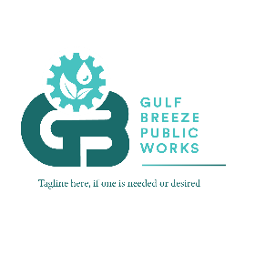**15. How does climate change affect stormwater management?** Climate change can lead to more frequent and intense storms, increasing runoff volumes, and the risk of flooding. Adapting stormwater systems to handle these changes is essential.