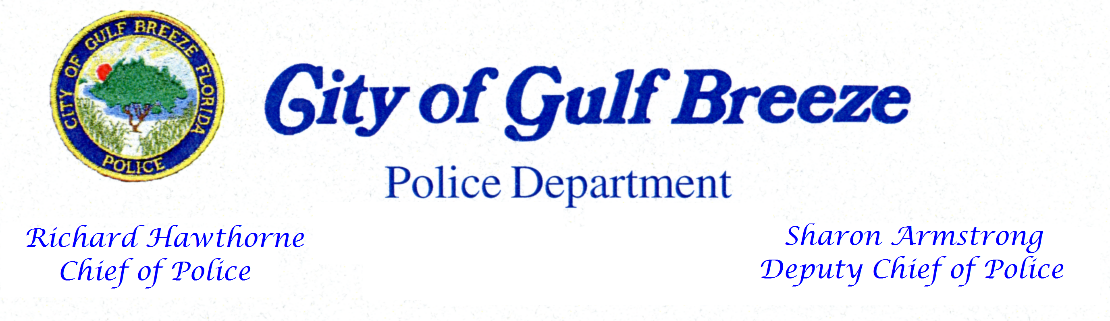

March 21,2023 Contact: Chief Rick Hawthorne Immediate Release (Phone #):859-934-5121

ACCREDITATION TEAM INVITES PUBLIC COMMENTS ABOUT
Gulf Breeze Police Department

Gulf Breeze: A team of assessors from the Commission for Florida Law Enforcement Accreditation (CFA) will arrive April 25,2023 to examine all aspects of the Gulf Breeze Police Departments policies and procedures, management, operations, and support services. Gulf Breeze Police Department has to comply with numerous standards in order to receive accredited status. Many of the standards are critical to life, health, safety issues, and best practices.

As part of the assessment, agency members and the general public are invited to offer comments to the assessment team. A copy of the standards manual is available on the CFA website at www.flaccreditation.org under the standards tab.

For more information regarding CFA or for persons wishing to offer written comments about the Gulf Breeze Police Department’s ability to meet the standards of accreditation, please send correspondence to: CFA, P.O. Box 1489, Tallahassee, Florida, 32302, or email to flaccreditation@fdle.state.fl.us.

The accreditation program manager for Gulf Breeze Police Department is Sgt Beth Goff. She said the assessment team is composed of assessors from similar agencies. The assessors will review written materials, interview individuals, and visit offices and other areas where compliance can be observed.

Once the Commission’s assessors complete their review of the agency, they report to the full Commission, which then determines if the agency is to receive accredited or reaccredited status. Gulf Breeze Police Department’s accreditation is valid for three years. Verification by the team that Gulf Breeze Police Department meets the Commission’s standards is part of a voluntary process to gain or maintain accreditation--a highly prized recognition of professional excellence, Chief Hawthorne said.

